REGISTRATION FLOW ON ROTARY INSTITUTE 2019
Without PayPal account process
- Go to https://2019manilarotaryinstitute.org/registration/
- On the registration form, input data on all required fields.
- Once done, click the “COMPLETE REGISTRATION” button.
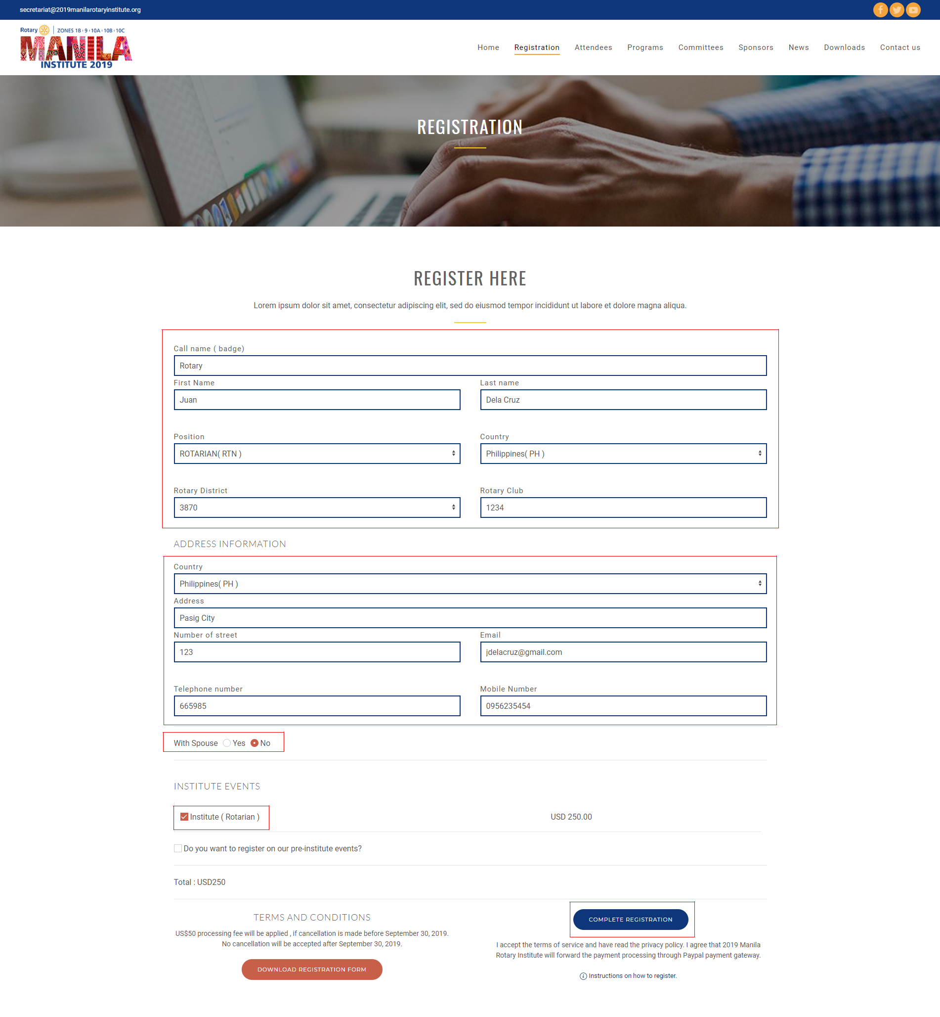

- After a successful registration, it will be redirected to PayPal login page. If you don’t have a PayPal account kindly click the “Pay with a Bank Account or Credit Card” button.
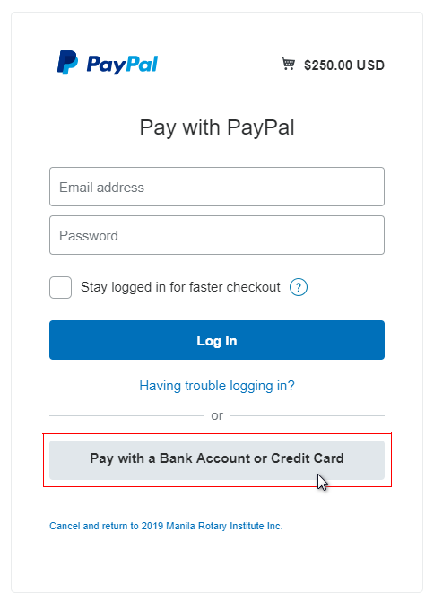

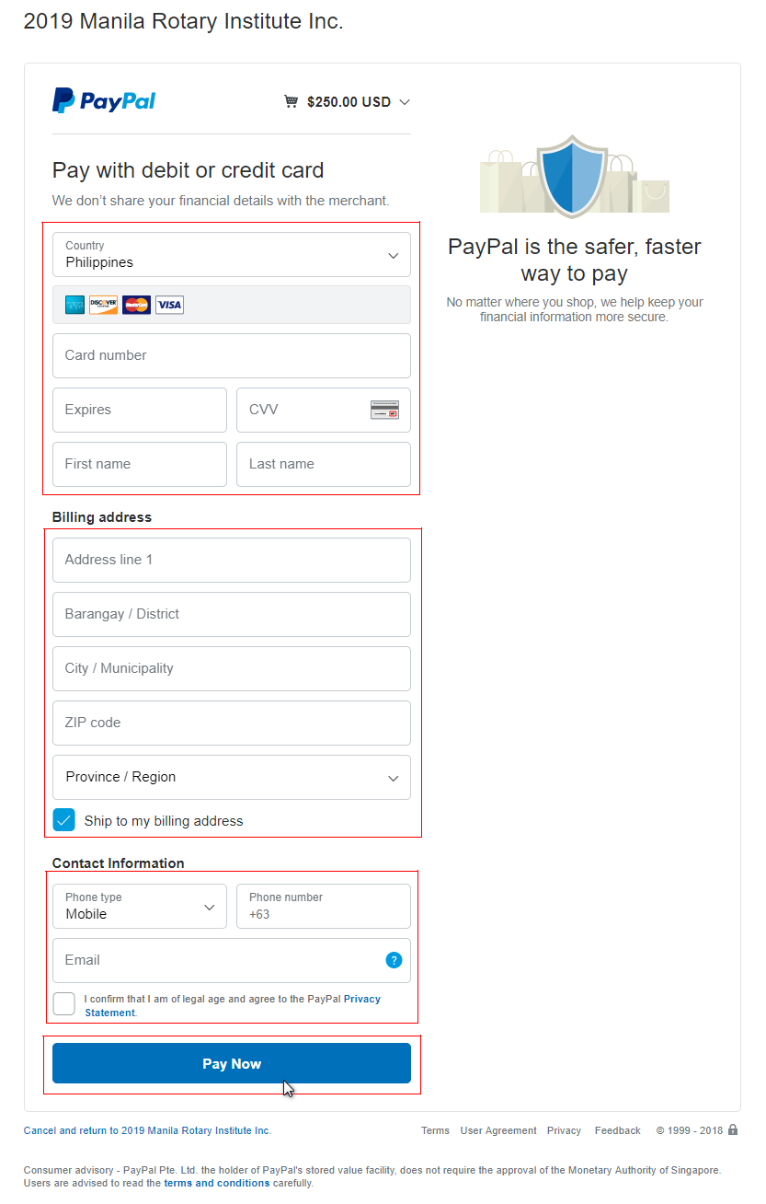
- It will be redirected to PayPal payment form. Enter data on all required field and agree on PayPal’s privacy statement. Once done, click the “Pay Now” button.
With PayPal account process
- Go to https://2019manilarotaryinstitute.org/registration/
- On the registration form, input data on all required fields.
- Once done, click the “COMPLETE REGISTRATION” button.

- After a successful registration it will be redirected to PayPal login page. On login form, enter your email address and password then click the “Log In” button.
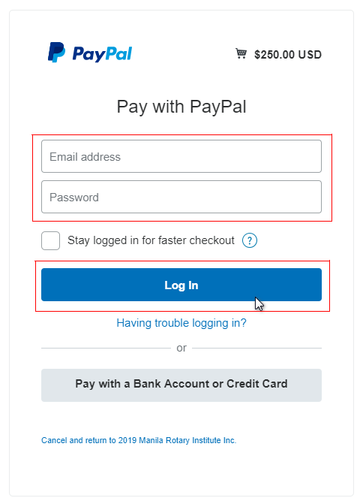

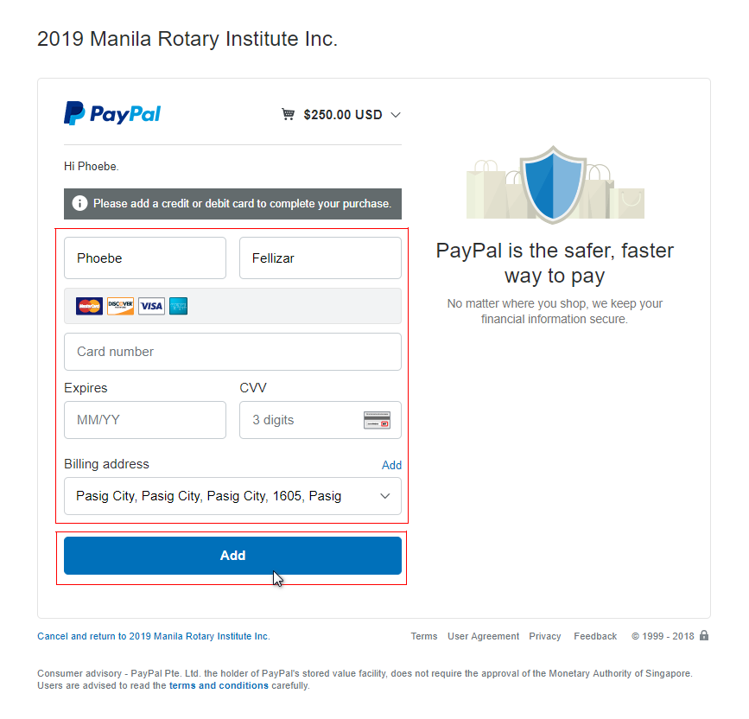
- After a successful login on your PayPal’s account it will redirect you to payment page. Enter data on all required field then click “Add” button.

